Technology Connected Lesson Plan

Title: Math Centers for Ratio/Proportions/Percents

Submitted By: Rhonda Schexnayder

Grade Level: 7

Curriculum Areas: Math

Standards:

Standard 1: Solves problems using a variety of strategies
Benchmarks
- Selects the appropriate formulas, equations, and inequalities to solve problems
- Uses proportional thinking (e.g., rates, scaling, similarity) to solve problems
- Follows a general problem-solving model for solving real-world problems

Standard 3: Uses basic and advanced procedures while performing the process of computation
Benchmarks
- Adds, subtracts, multiplies and divides rational numbers
- Converts between decimals, fractions and percentages
- Applies ratio, proportion and percent when solving problems

Technology Strategies:

Technology Problem-Solving and Decision-Making Tools (Problem Solving Foundation Skill)
- Students use appropriate technology resources for solving problems and making informed decisions.
- Students employ technology for real world problem solving.

Basic Operations and Concepts
- Students demonstrate a sound understanding of the nature and operation of technology systems.
Students are proficient in the use of technology.

Lesson Objectives: The student will:
- Write, revise and print math story problems using the Alpha Smarts.
- Find the ratio, proportion and percent of the letters in a handful of Alphabits cereal.
- Use ratios to determine the amount of each ingredient when converting recipes.
- Create a table and a graph using Excel.

Technology Connection: Alpha Smarts, Excel

Assessment:

Center One: Alpha Smart Activity
Printed paragraph (one per person)

Center Two: Post Alphabits Cereal Activity
Individual worksheets (one per person)
Group worksheet (one per group)

Center Three: Recipe Conversions
Group Worksheet (one per group)

Center Four: Computer Excel
Printout of Spreadsheet (one per computer)
Printout of Graph (one per computer)

Procedure:
Divide the class into 4 groups.
As a whole group the teacher should explain the procedures at each center.
Each group will begin at a different center.
Allow 25 - 30 minutes per center.
Have all needed materials at the centers before the students begin their rotation.
The direction sheets are self-explanatory at each center.
As time is called have the groups rotate to the next center.
This may be divided over a four-day period, where each group visits one center a day.

Materials:

Station One: Alpha Smart Activity
Alpha Smarts (one for each group member)
Printer cable
Printer
Computer paper
Direction sheet

Station Two: Post Alphabits Cereal Activity
Direction sheet
Hand full of Post Alphabits Cereal in plastic bags (one for each person in the group)
Paper Towels (one for each person in the group)
Direction sheet
Worksheets (1 individual per person and 1 group)
Calculators

Station Three: Recipe Conversions

Direction sheet
4 Recipes
Worksheets for each group
Calculators

Station Four: Computer Excel
Direction sheet
Computer with Excel
Computer Paper

Alpha Smart Activity

- Turn the Alpha Smart on.
- Type your name and the date.
- Type a paragraph using the criteria below.

You have been hired by a prominent textbook company because of your knowledge of Louisiana and of mathematics. Your first assignment is to write a story problem about Louisiana using the following mathematics terms.
- Ratio
- Proportion
- Percent
- Fraction
- Equation
- Variable
- Equals
- Decimal
- Numerator
- Denominator
- Spell check your document.
- Exchange Alpha Smarts with a partner and proof read each other's paragraphs.
- Make suggestions and corrections.
- Attach your Alpha Smart to the printer.
- Print out a single copy of your paragraph.

Post Alphabits Cereal Activity

At this station your group is going to perform a scientific investigation. You will apply the concept of ratio and percents to the distribution of letters contained in a box of Post Alphabits Cereal. Each member of the group should have a plastic bag with a sample of Post Alphabits cereal, a record sheet, and a piece of paper towel. Each person should empty their cereal on the paper towel and then tally the number of times each letter occurs and the total number of letters in their plastic bag. (DO NOT include Parts of letters!) Then write the tally on the record sheet, then write a ratio for the letter as a fraction and then convert the ratio to a percent. Once each member of the group has their individual record sheet completed, the group should complete a record sheet combining the group's totals.
Individual Alphabits Record Chart

Name: _________________________________

 | Count | Ratio | Percent

A
B
C
D
E
F
G
H
I
J
K
L
M
N
O
P
Q
R
S
T
U
V
W
X
Y
Z
Sample Total: ________________
Group Alphabits Record Chart

Names: _________________________________

 | Count | Ratio | Percent

A
B
C
D
E
F
G
H
I
J
K
L
M
N
O
P
Q
R
S
T
U
V
W
X
Y
Z
Group Total: ________________
Louisiana Cooking Adventure

Bon Appetite!

Directions: You are embarking on an adventure involving Louisiana cooking. Your group’s mission will be to prepare a banquet for 200 relatives and friends that are coming to the Second Annual Cajun Animal Race to be held at the local park and the Knights of Columbus Hall next month. The banquet will consist of four main dishes: Turtle Soup, Alligator Sauce Piquant, Pot Roasted Rabbit, and Pecan Pies.

At this station you will find the recipes needed to prepare these four dishes. You will be responsible for two dishes (Alligator Sauce Piquant and Pot Roasted Rabbit OR Turtle Soup and Pecan Pie). You will determine the amount of ingredients needed to prepare these dishes to feed 200 people. Four master ingredient sheets are included at this station. Use one to record your results after determining the appropriate quantities. You may use the calculators provided. As a group you need to decide which dishes you will prepare. (Alligator Sauce Piquant and Pot Roasted Rabbit OR Turtle Soup and Pecan Pie).

Here are some hints to help you get started:

- Determine how many people your recipe serves.
- Set up a proportion involving each ingredient, the number of people served by the recipe, and the number of people attending the banquet.
For example: 4 eggs / ? eggs = 6 people / 125 people
- Solve the proportion; checking your answer using the calculator. Does your answer make sense in the recipe? Since you are feeding more people, is your answer reasonable?
- When determining amounts using fractions, change the fractions to decimals before setting up the proportion.
- Change the decimals back to fractions before recording the amount of the ingredient needed for the banquet.

Alligator Sauce Piquant and Pot Roasted Rabbit Ingredient Sheet
Louisiana Cooking Adventure

Names: __________________________________________________

Directions: Use the empty space next to each ingredient to set up the proportions needed to solve for the new quantity needed to serve 200 people. Write the new quantity on the line to the left of the ingredient.

Alligator Sauce Piquant

__________lb. alligator tail, preferably the white center meat of the tail

__________large onions, chopped fine

__________cloves garlic, minced

__________stalks celery, chopped fine

__________large green peppers, chopped fine

__________eight-ounce (227 gram) can tomato sauce

__________cup (60 ml) vegetable oil

__________teaspoon (5 ml) Tabasco

__________tablespoon (15 ml) Worcestershire sauce

Salt, black and red pepper to taste.

Pot Roasted Rabbit

__________wild rabbit(s)

__________Tablespoons vinegar

salt

pepper

__________cloves garlic

__________strips bacon

cooking oil

__________cups chopped onion

__________cups chopped bell pepper

__________Tablespoons chopped parsley

__________medium cans mushrooms

__________teaspoons butter

__________cups beef or chicken bouillon

__________Tablespoons onion tops

__________teaspoons dry mustard

__________teaspoons sugar

__________teaspoons Worcestershire sauce

Turtle Soup and Pecan Pie Ingredient Sheet
Louisiana Cooking Adventure

Names: __________________________________________________

Directions: Use the empty space next to each ingredient to set up the proportions needed to solve for the new quantity needed to serve 200 people. Write the new quantity on the line to the left of the ingredient.

Turtle Soup

__________ pounds turtle meat

__________ quart(s) hot water

__________teaspoons salt

__________ teaspoons pepper

__________onions, sliced

__________whole cloves stuck into one garlic pod

__________bay leaves

__________slices lemon

__________cups oil

__________cups flour

__________cups onion, chopped fine

__________cups celery, chopped fine

__________ garlic, minced

__________bunch green onions, chopped

__________cups parsley, chopped

__________(28 oz) cans whole tomatoes, chopped

__________(6 oz) cans tomato paste

__________quart turtle stock

__________Tablespoons Worcestershire sauce

__________Tablespoon salt

__________teaspoon cayenne pepper

__________quart hot water

__________slices lemon

__________hard boiled eggs

Pecan Pie

__________eggs

__________cups sugar

__________rounded tablespoons flour

__________cups dark corn syrup

__________teaspoons vanilla

__________cups pecans

__________unbaked 9 – inch pie shells

Alligator Sauce Piquant  (Serving for Four) | 
Ingredients:

2 lb. alligator tail, preferably the white center meat of the tail

2 large onions, chopped fine

4 cloves garlic, minced

5 stalks celery, chopped fine

2 large green peppers, chopped fine

1 eight-ounce (227 gram) can tomato sauce

1 cup (60 ml) vegetable oil

1 teaspoon (5 ml) Tabasco

1 tablespoon (15 ml) Worcestershire sauce

Salt, black and red pepper to taste

- Remove all fat from alligator meat and cut into bite-sized pieces. Set aside.

- Sauté' onions, garlic, celery and green pepper in oil until tender.

- Add all remaining ingredients except meat and simmer slowly in a covered pot for about 30 minutes.

- Add alligator meat and continue cooking for an additional 1 1/2 hours. Allow to cool to room temperature.

- Reheat to serve over rice.

Recipe by Ms. Charlotte Lefebvre from Sulphur, LA.
Tiger Bait Recipes, LSU Alumni Association, 1976.

Pecan Pie  (1 pie - serves Six) | 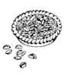
Ingredients:

3 eggs

1/2 cup sugar

1 rounded tablespoon flour

1 1/2 cups dark corn syrup]

1 teaspoon vanilla

1 cup pecans

1 unbaked 9-inch pie shell

- Beat eggs. In a separate bowl, mix the sugar and flour together. Be sure to mix well. Add the sugar mixture to the eggs.
- Add the corn syrup and vanilla and mix well.
- Add the pecans; fold carefully into the rest of the mixture.
- Pour into a unbaked 9-inch pie shell.
- Bake at 325º for 45 to 60 minutes, or until filling is set. Do not overcook.

Recipe by Marcelle Bienvenu from Who's Your Mama, Are You Catholic, And Can
You Make A Roux?, 1991.

Pot Roasted Rabbit

(Serving for Eight)

Ingredients:

1 wild rabbit

1 Tablespoon vinegar

salt

pepper

1 clove garlic

4 strips bacon

cooking oil

1/4 cup chopped onion

1/4 cup chopped bell pepper

2 Tablespoon chopped parsley

1 medium can mushrooms

1 teaspoon butter

2 cups beef or chicken bouillon

2 Tablespoons onion tops

1/2 teaspoon dry mustard

1/2 teaspoon sugar

1/2 teaspoon Worcestershire sauce

- Prepare and season rabbit one hour ahead of time: Sprinkle rabbit with vinegar, let set for a few minutes, rinse and wipe. Cut into serving pieces, rub with cut clove of garlic, salt and pepper.
- Cut bacon into 1-inch pieces, brown in iron pot, remove and set aside. Lightly flour rabbit and pan fry until well browned, adding as much oil as necessary. Remove rabbit; pour off oil, retaining about 1 tablespoonful; and sauté onions, celery, bell pepper and parsley until onions are soft. Meanwhile, brown mushrooms in butter. Return rabbit to pot, adding mushrooms and 1/2-cup liquid. Cover and simmer slowly1 hour to 1 1/2 hours or until tender. Turn rabbit occasionally, adding liquid as necessary. Return bacon to pot if desired.

- To make gravy, remove rabbit from pot, add rest of ingredients, add more liquid with flour to thicken, enough to make about 2 cups gravy. Simmer about 15 minutes. Pour gravy over rabbit, or serve with rice.

Recipe by Robert C. Pettit from Talk About Good! Cookbook, 1969

Turtle Soup

(Serving for Eight)

STEP 1 Ingredients:

3 or 4 pounds turtle meat

1 quart hot water

1 teaspoon salt

1 teaspoon pepper

1 onion, sliced

3 whole cloves stuck into one garlic pod

4 bay leaves

1 slice lemon

STEP 2 Ingredients

2/3 cup oil

2/3 cup flour

STEP 3 Ingredients

2 cups onion, chopped fine

1 cup celery, chopped fine

4 cloves garlic, minced

1 bunch green onions, chopped

1/4 cup parsley, chopped

STEP 4 Ingredients

1 (28 oz.) can whole tomatoes, chopped (drain and reserve liquid)

1 (6 oz.) can tomato paste

1 quart turtle stock

4 Tablespoons Worcestershire sauce

1 Tablespoon salt

1 teaspoon cayenne pepper

1 quart hot water

2 slices lemon

STEP 5 Ingredients

6 hard boiled eggs

1. Place turtle meat, water, salt, pepper, onion, cloves/garlic, bay leaves and lemon in 3 quart dish. Cover. Microwave on HIGH 30 minutes or until turtle meat is tender. Remove meat from bone and mince, strain stock and reserve. Set aside. (This could be done the day before and refrigerated.)

2. Make a Roux with oil and flour. Mix together in a 4-cup measure. Cook on HIGH 6-7 minutes. Stir.

3. Add onion, celery, garlic, onion tops and parsley. Cook on HIGH 5 minutes. Stir during cooking time. Now pour Roux into a larger dish (4 or 5 quart).

4. Add tomatoes and paste to Roux. Cook on HIGH 10 minutes. Add turtle meat, stock, tomato liquid, Worcestershire sauce, salt and pepper. Cover with wax paper. Cook HIGH 30 minutes. Stir once. Add water and lemon. Cover and cook on HIGH 30 minutes.

5. Sieve egg yolks. After serving soup, place one heaping tablespoon of yolk in each bowl.

Recipe from Tout de Suite à la Microwave by Jean K. Durkee, 1977.

Excel Spreadsheet Computer Activity

Your group is going to calculate the cost of gasoline for a journey across Louisiana. Each weekend the travelers will be leaving on Friday from New Orleans and traveling to another Louisiana city and then returning to New Orleans from that city on Monday. This will continue for 5 weeks. You are to create a Spreadsheet in Microsoft Excel to calculate all of the gasoline expenses for you.

- Open Excel. (Click the blue X on the task bar or Click on Start, Programs, Microsoft Excel)
- Type the following data into the appropriate cells (A cell is the intersection of a row and a column – A1, B1, etc.) To size the column to fit the larger words: move your cursor to the line between the two column headers (A and B), your mouse will turn into a cross, double click. This method will size the column to fit the longest text of the column.
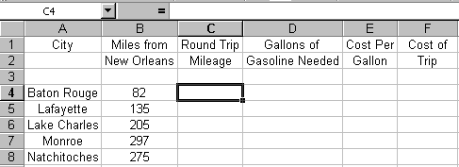

We need to Multiply the miles times two for the round trip mileage.
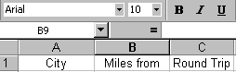
- Click on cell C4.
- Click on the equal sign above the column headers. This equal sign symbolizes to the computer that a formula will now be typed in the cell.
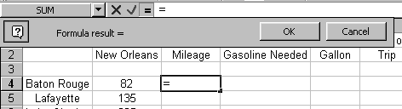
- Your screen should look like this.

- Click on cell B4 (it has the 82 in it).
- Type the *.
- Type a 2.
- Your screen should look like this.
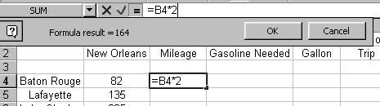

- Press the enter key and your answer should appear in this cell.
- Click on cell C5.
- Click on the equal sign.
- Click on cell B5 (it has the 135 in it).
- Type the *.
- Type a 2.
- Press the enter key and your answer should appear in this cell.
- Continue the above process to write the formula for the remaining three cities.
- Your screen should then look like this.
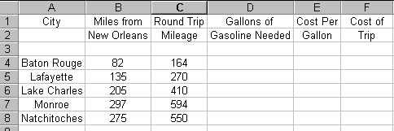

We are going to assume that the car the travelers will be using gets 25 miles to the gallon of gasoline. We now need to calculate the gallons of gas needed. This is done by dividing the round trip mileage by 25.
- Click on cell D4.
- Click on the equal sign.
- Click on cell C4 (it has the 164 in it).
- Type the / (this is the symbol for division).
- Type 25.
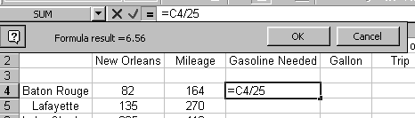
- Your screen should look like this.

- Press the enter key and the answer should appear in this cell.
- Continue this process for the remaining 4 cities.
- Your screen should then look like this.
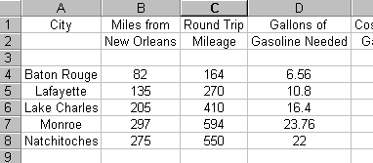

We are going to assume that the average price per gallon of gasoline is $1.45. We now need to calculate the cost of gasoline. This is done by multiplying the number of gallons by 1.45.
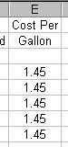
- Type 1.45 in all of the cells E4 through E8.

- Click on cell F4.
- Click on the equal sign.
- Click on cell D4.
- Type the *.
- Click on cell E4.
- Press the enter key. Your answer should appear in this cell.
- Continue the process until the remaining 4 cities are calculated.
- Highlight column F.
- Click on the Format menu.
- Click on cells.
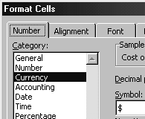
- Click the number tab.
- Click currency.

- Type your name(s) into cell A12.

We are now going to create a pie graph to show the percent each trip is in relation to the total spent.
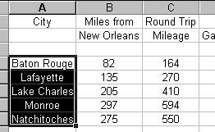
- Highlight cells A4 through A8.

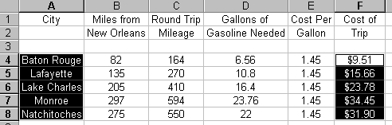
- Hold the ctrl key down.
- Highlight cells F4 through F8.

- Click on the graph icon.

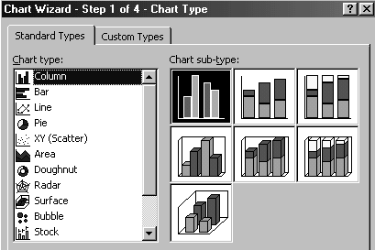
- Click on Pie under the Chart Type.

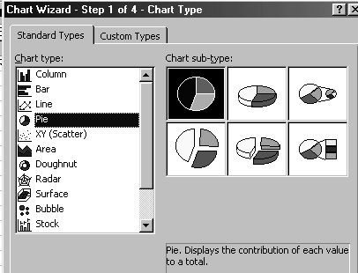
- Select a chart sub-type.

- Click Next.
- Click Next.
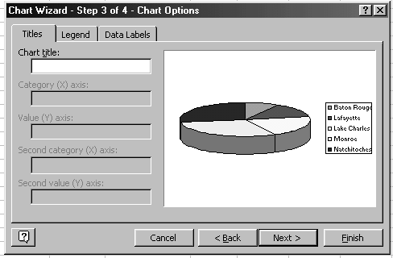
- Type a title for your graph.

- Click on the Data Labels tab.

- Click Show Percents.
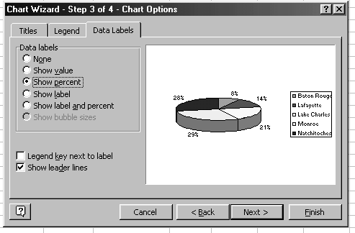

- Click Next.

- Click as New Sheet.
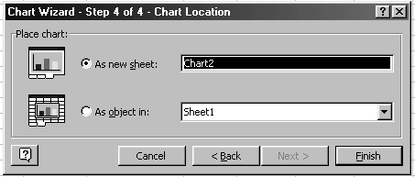

- Click Finish.
- Click Insert Menu.
- Click Picture.
- Click Word Art.
- Make a selection.
- Type your name(s).
- Size and move the word art to the upper left corner.
- Change font, size and color if you wish.
- Print your graph.
- Switch back to your spreadsheet by clicking on the tab labeled sheet1.
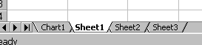

- Print your spreadsheet.

