Names: ____________________________________________

Date: ______________________________________________

Fruit for Thought

Using the Fruit for Thought Problems determine which fruit corresponds to which number in each equation. Use only the numbers 0 though 9. Remember there is a unique number that corresponds to each fruit. Under the picture of each fruit below, write the number that corresponds to it. As you determine the values write down your group’s process in making that determination. What were you thinking? Use the back of this sheet if necessary.

Extension: What math properties did this exercise use?
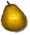

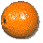


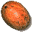
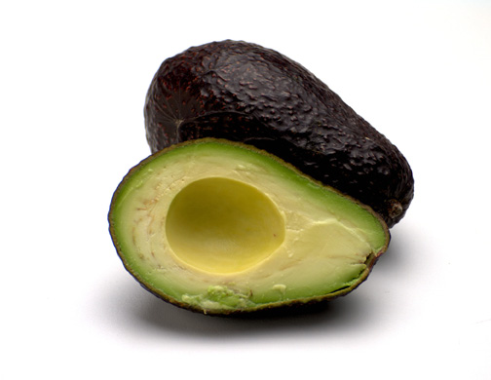



Fruit For Thought Problems
+ + =
+ =
² =
+ =
- =
x =
/ = , >

Station 1

“Fruit for Thought”

- One sheet per group should be turned in
for a grade.

- Use scratch paper to figure out the solution.

- Write your reasoning process on the
worksheet. Use the back of the worksheet
if necessary.

Station 2

“Brain Teasers”

- One sheet per person.

- Follow the directions on the worksheet.

- The sheet asks you to write or sketch your solution.

- One sheet should be turned in for a grade.

- Be sure to put your name of your worksheet.

Station 3

“What do Americans eat?”

- Directions are next to the computes.

- Follow the directions on the worksheets.

- Print one copy of your graph to turn in
for a grade.

What do Americans Eat?

To Create a Spreadsheet:
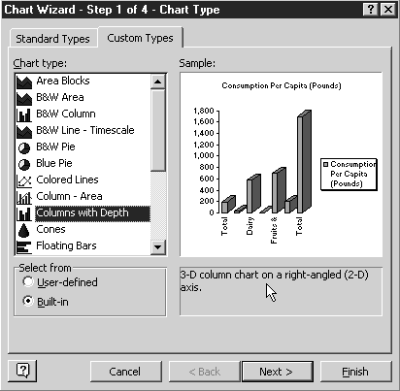
- Click on the Start Menu.
- Click on Programs.
- Click on MicroSoft Excel.
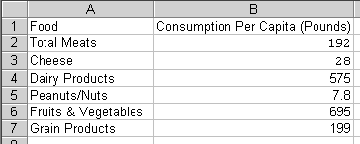
- Type the following data into the cells. Press the enter key after each word. Use the arrow keys to get to column B.
- If the label is too long for the column.
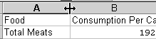
- Move your mouse to the gray line between the A and the B. The mouse pointer will turn into a black line with two arrows pointing outwards.
Click and hold the mouse as you drag the line until all of the text shows in column A. Repeat this process for column B.
- Center the data in each cell. This is done by highlighting the cells and clicking on the center icon located on the tool bar.
- Bold the labels. This is done by highlighting the cells with the labels and clicking on the bold icon located on the tool bar.
- Click in cell A8.
- Type the words Total Pounds Consumed.
- Highlight cells B2 through B8.

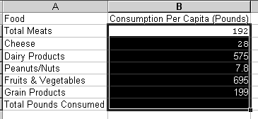
- Click on the AutoSum tool located on the toolbar.

To Create a Custom Bar Chart:
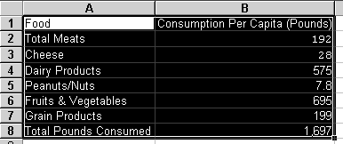
- Highlight the data in the chart. (Cells A1 through B8)
- Click on the Chart Wizard icon on the toolbar.
- In the Chart Types window, click on the Custom Type tab. Scroll down the list and select Columns with Depth from the Chart Type list.
- Click on the Next button.
- Click on the Next button again.
- Type Foods Consumed by Americans in the Chart Title box.
- Type Food Category in the Category (x) axis box.
- Type Pounds in the Value(z) axis box.

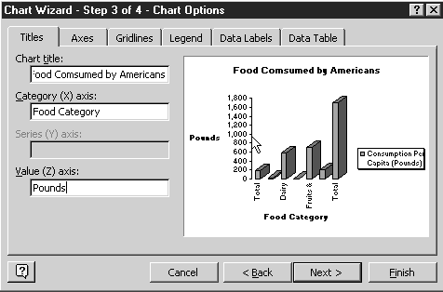
- Click on the Legend tab.
- Click on the Show Legend box to uncheck it.

- Click on the Next Button.
- Click on the As New Sheet Option.
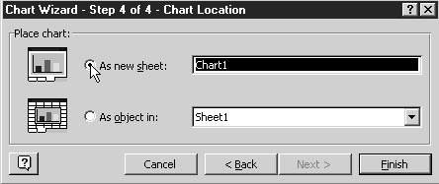

- Click on the Finish button.

To Change the color of the bars:

- Click on one of the bars once.
- Click on the bar again.
- Double click that same bar.
- Click on the color you want.
- Click OK.
- Double click on each of the other bars.
- Make changes.

To Change the Fonts:

- Click on any word.
- Click on the Format menu.
- Click on Selected Axis.
- Click on the Font Tab.
- Click on desired changes.
- Click on the Alignment Tab.
- Click on the desired changes.
- Continue on all words.

To Add Names:

- Click on the Insert Menu.
- Click on Picture.
- Click on Word Art.
- Click on the style you want.
- Type your names.
- Click OK.
- Size and move your names to the corner.

To Print:
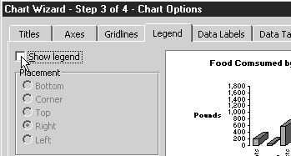
- Click on the File menu.
- Click on Print.

