Tangram Designs
Remember that the pieces may be rotated or flipped over during the rearrangement.
Christmas Tree  Rearrange the seven tangram pieces to form the shape of a Christmas Tree as shown below:  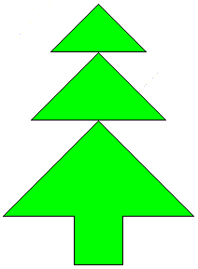 | Candle  Rearrange the seven tangram pieces to form the shape of a Candle as shown below:  
Mountain Sunrise   | 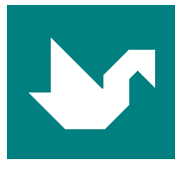  Swan
Rabbit  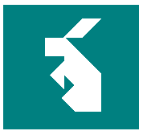 | 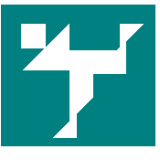  Man
Cat  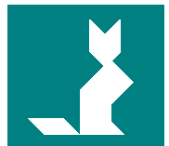 | 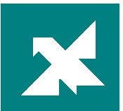  Bird

