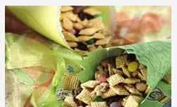


Shake ’n Go
Snack Mix

Crunchy, sweet and delicious, this recipe has the added benefit of not needing any cooking at all.

Ingredients

5 cups Chex® cereal (any variety)
1 cup teddy bear-shaped graham snacks
1/2 cup honey-roasted peanuts
1/2 cup raisins
1/4 cup candy-coated chocolate candies or jelly beans

Place all ingredients in large resealable plastic food-storage bag. Shake until well mixed. Store sealed in plastic bag or airtight container. 7 cups snack.

Center Directions:

- You are to make only 1/3 of the recipe!

- Write your new ingredient amounts on your worksheet, before you begin to combine them! Be sure to show your work in the space provided.

- Once the mix has been shaken, pour each group member some into their bowl.

- Enjoy!

