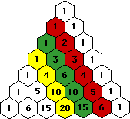
The Twelve Days of Christmas
and Pascal’s Triangle

Objective: Use Pascal’s Triangle to find out how many items were given in the song, “The 12 Days of Christmas.”
Procedures:
Step 1: Look for the pattern in Pascal’s Triangle and write the correct number in all of the remaining spaces. Be sure to record your answer on the student worksheet.
Step 2: On your student worksheet, color the indicated diagonal red.  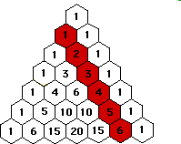 | This diagonal of Pascal’s triangle indicates the number of new gifts given on the consecutive days.  1 partridge in a pear tree  2 turtle doves  3 French hens  4 calling birds  5 gold rings  6 geese a-laying  7 swans a-swimming  8 maids a milking  9 ladies dancing  10 lords a-leapin  11 pipers piping  12 drummers drumming
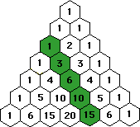  Step 3: On your student worksheet, color the indicated diagonal green. | The green diagonal of Pascal’s triangle indicates the combined gifts given on the consecutive days.  1 = 1 partridge in a pear tree 3 = 2 turtle doves + 1 partridge in a pear tree  6 = 3 French hens + 2 turtle doves + 1  partridge in a pear tree  10 = 4 calling birds + 3 French hens + 2  turtle doves + 1 partridge in a pear tree  15 = 5 gold rings + 4 calling birds + 3 French hens+  2 turtle doves + 1 partridge in a pear tree
Step 4: On your student worksheet, color the indicated diagonal yellow.  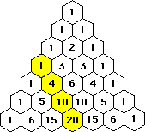 | The yellow diagonal of Pascal’s triangle indicates the total number of gifts given.  1 = 1 partridge in a pear tree  4 = 2 turtle doves + 1 partridge in a pear  tree + 1 partridge in a pear tree  10 = 3 French hens + 2 turtle doves + 1  partridge in a pear tree + 2 turtle doves  + 1 partridge in a pear tree + 1  partridge in a pear tree  20 = 4 calling birds + 3 French hens + 2 turtle doves  + 1 partridge in a pear tree + 3 French hens + 2  turtle doves + 1 partridge in a pear tree + 2  turtle doves + 1 partridge in a pear tree+ 1  partridge in a pear tree

