Turn Your Classroom into a Video Production Studio with
Microsoft Producer

St. Charles Parish Schools
Dr. Rodney Lafon, Superintendent
NECC June 21, 2004
1:30 – 4:30

Colleen Charles – ccharles@stcharles.k12.la.us
Elaine Fitzgerald – efitzgerald@stcharles.k12.la.us
Lisa Perrin – lperrin@stcharles.k12.la.us
Rhonda Schexnayder – rschexnayder@stcharles.k12.la.us
Vanessa Terry – vterry@stcharles.k12.la.us
Producer Workshop

What is Producer?
- Add-on PowerPoint
- Save as web page (HTML)
- Can be viewed in Internet Explorer, Netscape or IE for Mac
- Only created on PC
- Works with PowerPoint XP or 2002
- Required Windows 2000 or above

Components of Producer
PowerPoint
- Storyboarding – planning (recommended)
- Slide rule:
5 words per line
5 lines per slide
- Limit animation – do not use mouse clicks, use timings.
- Multimedia Rubric (recommended)

Video
- Video
- Digital Video Camera
or
- Digital Camera with Audio/Video capabilities

Before Beginning your Production

Create a folder on the desktop

Place your PowerPoint in that folder

If you are using pre-done video clips from a service such as unitedstreaming or taking videos to disk, place your videos in the folder.
If you are going to “capture” your video, this will be done during the process of creating your Producer project.

How to Use Producer

To Begin a New Production
- Click Start
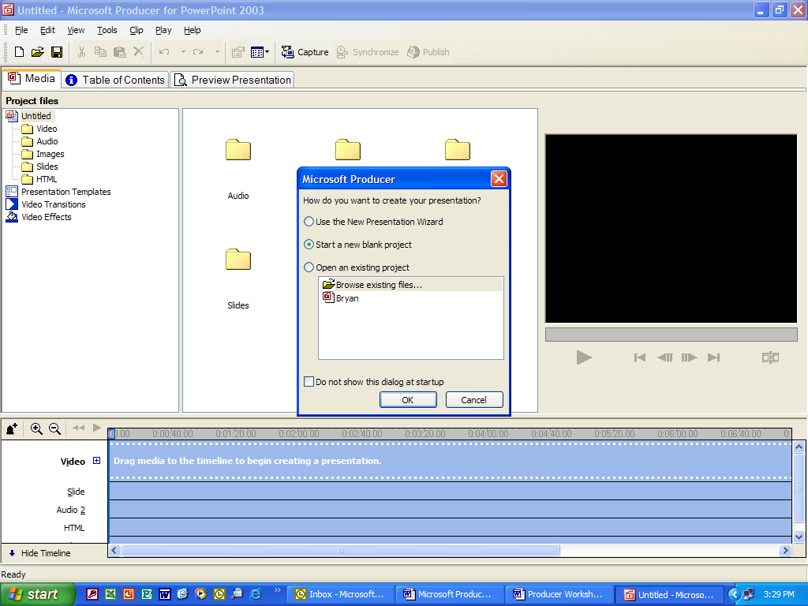
- Click All Programs
- Click Microsoft Producer

This screen will appear:
- Click in Use the New Presentation Wizard
- Click OK
- Click Next

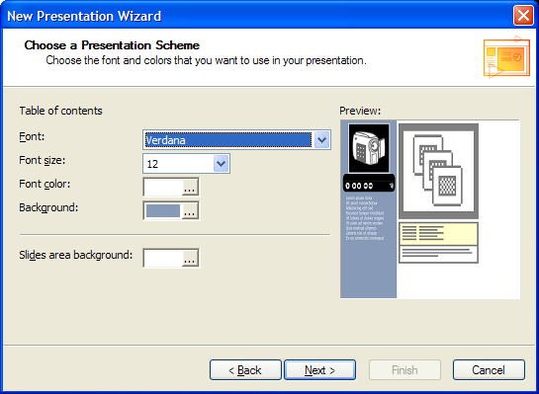
- Choose a Presentation Template that includes video and PowerPoint
- Click Next

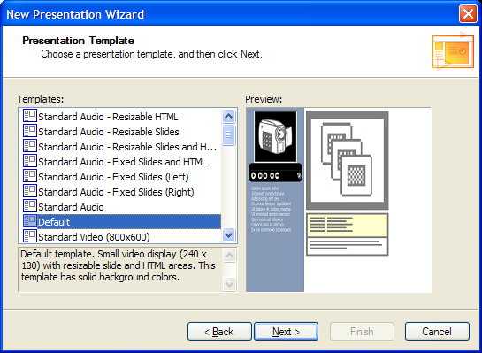
Choose Your Presentation Scheme
- Choose your Font
- Choose a Font size
- Choose Font Color
- Choose your Background Color
- Choose your Slide Area Background
- Click Next

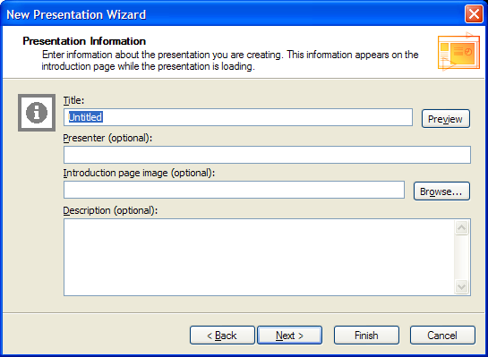
- Create a Title for your Production
- You may choose to include a picture
- You may choose to fill in the other optional items.
- Click Next

The next steps of the wizard take you through choosing the location of your PowerPoint and your Video

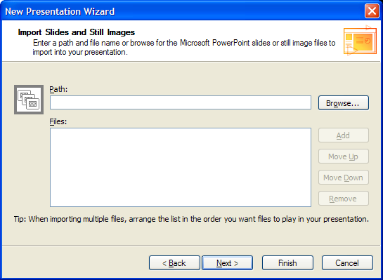
Choose your PowerPoint or Still Images
- Click on Browse
- Choose your PowerPoint or images
- You can choose more than one PowerPoint, continue to add them.
- Click Next

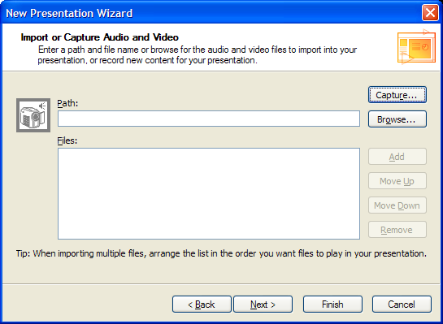

Import or Capture Audio and Video
- If you have pre-done videos click on Browse
- Choose your videos
- Repeat the process until all of your videos are listed.
- Use the Move Up/Move Down to select the order.

Click Capture to “capture your video from a video camera”
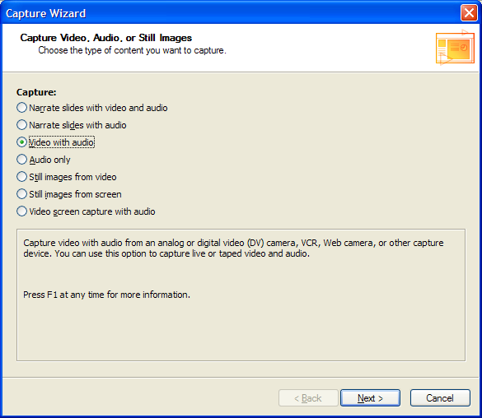
- Choose Video With audio
- Click Next

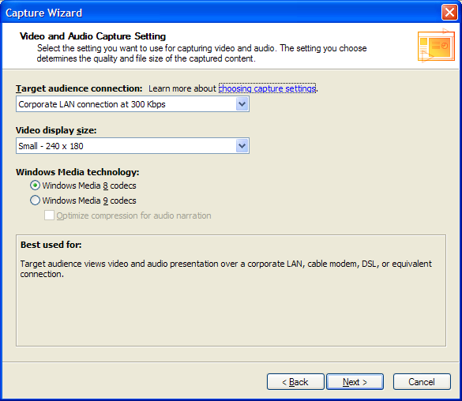
Choose your Capture Setting

- Use the pull down menus to choose your audience connections speed
- Video Display Size
Choosing a higher speed and larger video size will improve the quality, but will increase the file size.
The file can be compressed during the publishing stage.

A recommendation is to choose the video size based on the presentation template you have selected.

Windows Media Technology
Windows Media 8 – will work with older browsers
Windows Media 9 – has some additional features, but will only work on computers running Internet Explorer 5 and Windows Media Player 9
Click Next

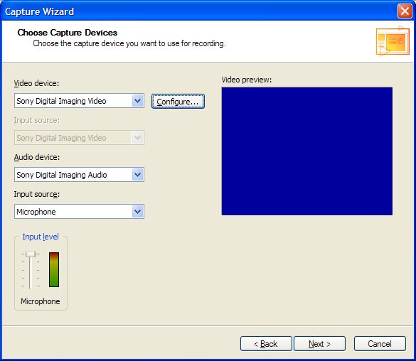

Choose your Video device
Choose your Audio device –
Click Next

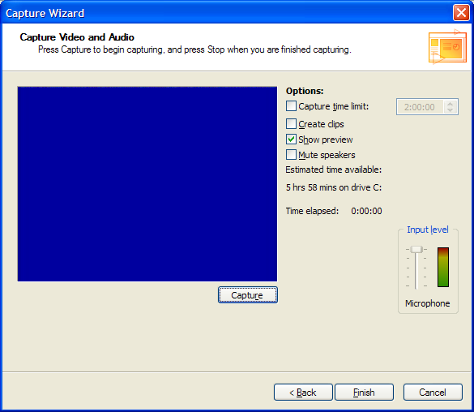

Choose the Options
For long videos, you may want to have it create clips for you
- Click Capture
- Click Stop
- Name your file
- Choose your folder
- Save the file
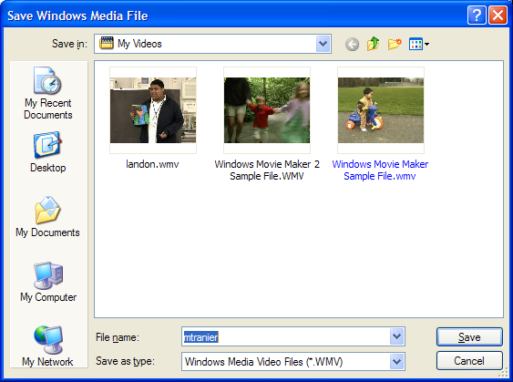
Repeat the process as needed
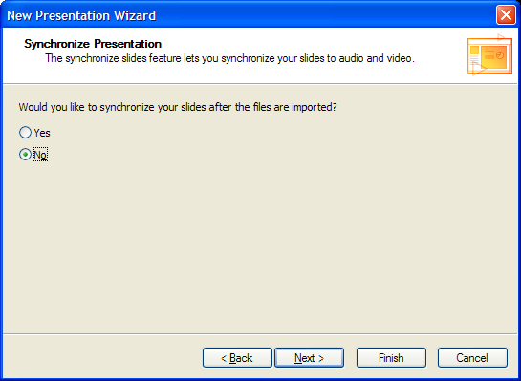
Click Finish

Choose No
We will synchronize the presentation later.

Click Finish
The files will be added to your timeline

The presentation will open into the preview mode.

The tabs across the top allow us to move between Media, Table of Contents and Preview Presentation
Click on the Media tab
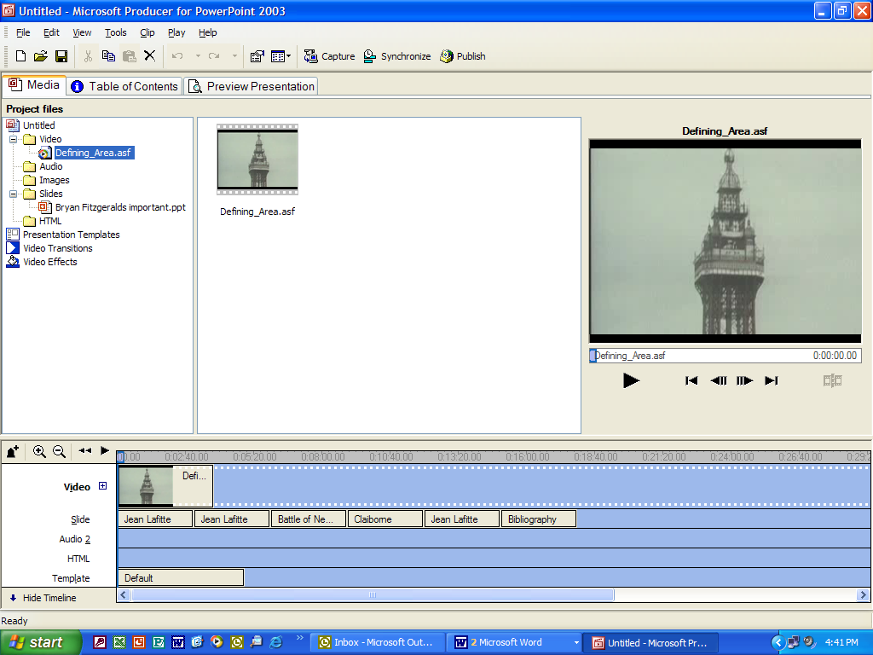

You can also add Video, Images, Audio, Slides or HTML without using the Wizard

To Import Video, Images, Audio, PowerPoint or Html
- Click on folder for that item, such as Video
- Click Import
- Choose File in: (Video will be on A:3½ floppy, PowerPoint on Desktop)
- Highlight all the files you want and click open.

- You can add a second audio track to play background music, etc. To adjust the tracks click on Tools and Audio Levels.
- If you have clips that have are recorded at different levels you can “normalize” your audio levels by clicking Tools and Normalize Timeline Audio

Drag Into Producer
- Drag and drop the added items or clips into the timeline.

Other Tools
Video Transitions
- Video Transitions can be added between each video
- Click on the Transition and drag it between the videos on the transition toolbar

Video Effects
- Click on Video Effects
- Click and Drag the Effect on top of the video you want it applied

Simple Audio/Video Effects
To mute, fade in or fade out
- Click on Clips
- Choose Audio or Video
- Choose the Effect
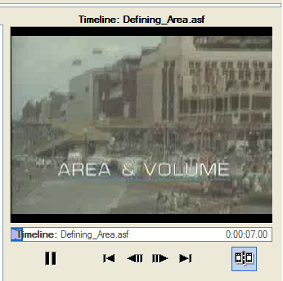
Editing Video
- Click on the Video
- Click on Play
- Use the Split Icon to clip the video
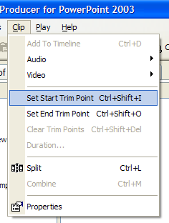
- You can also use the Set Start Trim Point and Set End Trim Point under Clip

When you have all of the parts of your presentation choose Synchronize
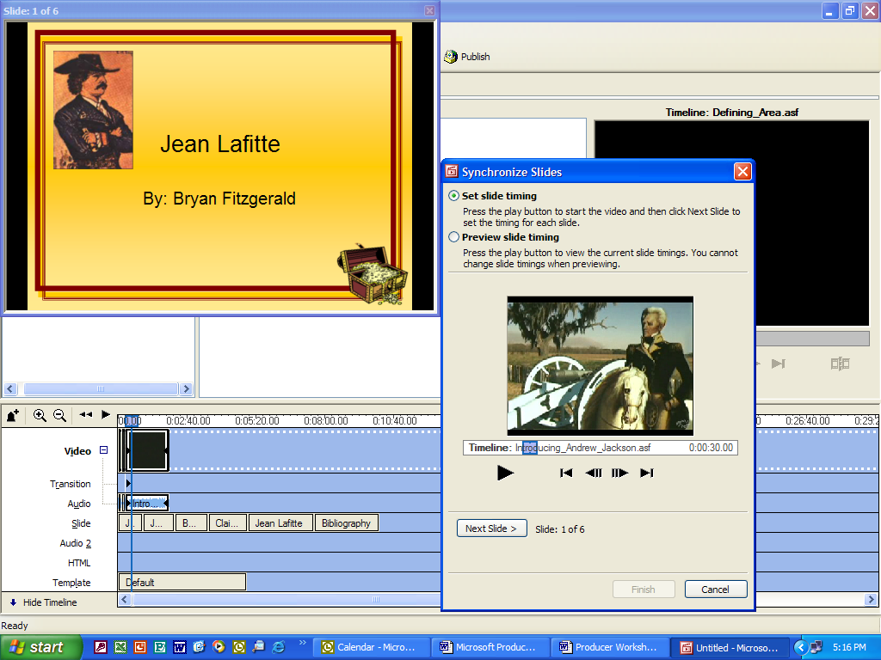
- Click the Play button
- Choose Next Slide as you want the next slide to appear.
- Click Finish when it is completed

Publishing Your Presentation
You will have many choices when publishing your presentation. Some things to keep in mind are:
- Who is your audience?
- Is it for local playback or playback on the web?
- How does your population access the web? Large DSL/Cable population? Dial Up?
- How clear does the video have to be?

- Click File
- Click Publish
- Click My Computer
- Click Next
- Name your file
- Click Browse and choose your Folder
- Create another folder inside of your folder for the completed presentation
- Click Next
- Name your presentation
- Complete the other information you would like included
- Click Next
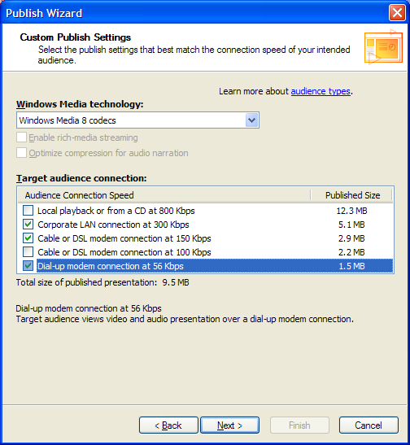
- Choose the size of the presentation
- You can use the recommended settings or Choose your own settings
- Click Next
- Choose multiple settings to address the variety of audiences (if needed)
- Notice the size that corresponds with the audience connection speed.
- Click Next to Publish the Files
- You can choose to Preview Your Presentation in a browser
- Click Finish

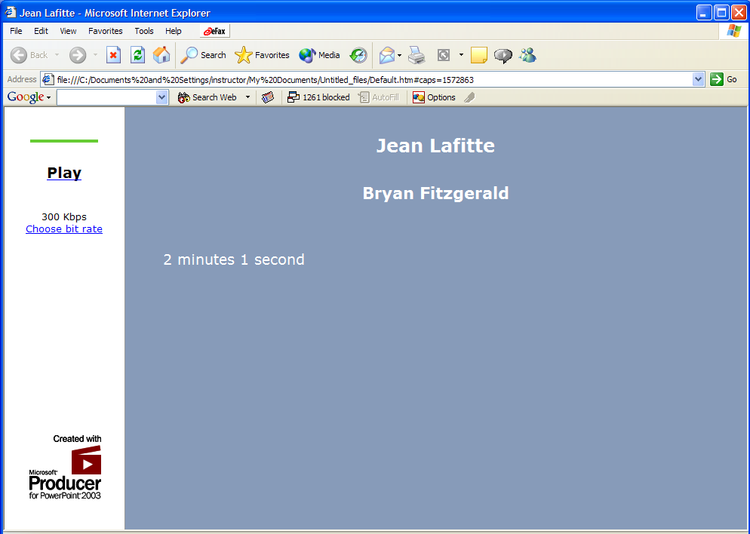
Your completed Presentation will look similar to this:

If you click on choose bit rate, you can choose playback rate.

Save the project to edit it at a later time by click on File and Save Project.

The publication produces a file and a folder with all of the parts inside of it. To publish to the web, publish both the folder and the file.

