Using Exchange to Check Your St. Charles Parish Email

You can check you St. Charles Parish Email from any computer that has an Internet connection.

- Open your Internet Connection – Netscape, Internet Explorer, America On-line, etc.
- Go to the District Website –
- Click on District select Check District Web Mail
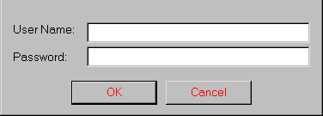
- A small window will appear
- Type in your user name (first initial, last name)
- Type in your password
- Click OK

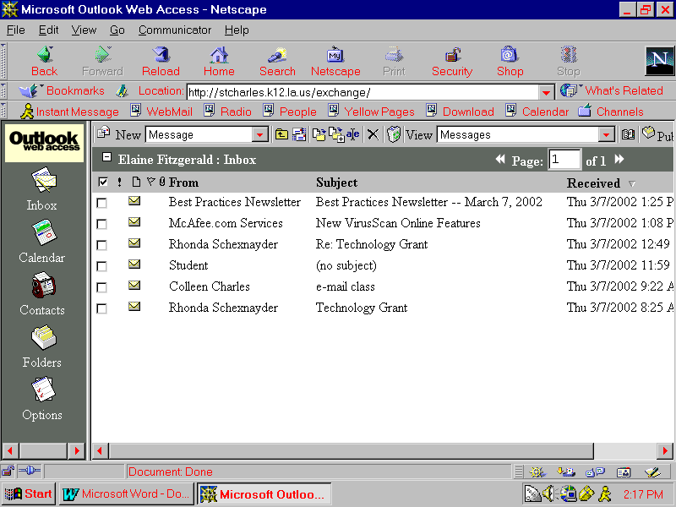
Your messages will appear
Click on the message to read your message
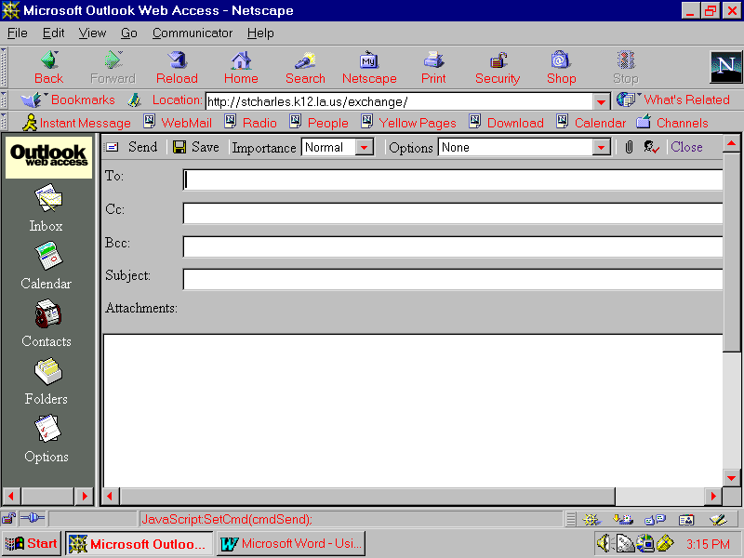
To Send a New Message
- Click on New
- Fill in the information
- Click Send – to send the message

To add an attachment
- Click on the paperclip
- Click Browse
- Select the file to send
- Click Attach
- Click Send

To delete a message
- Click on the message click the X
- Click in the boxes in front of the messages to delete
- Click on the X

To delete your trash
- Click on the Trash Can

To empty your sent mail
- Click on Folders
- Click on Sent Items
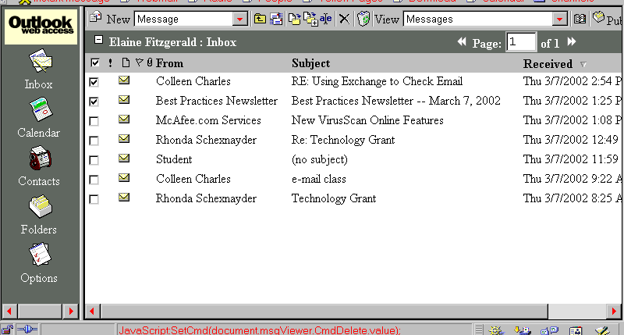
- Place a check in the boxes of the sent mail to delete
- Click on the X

To add a contact
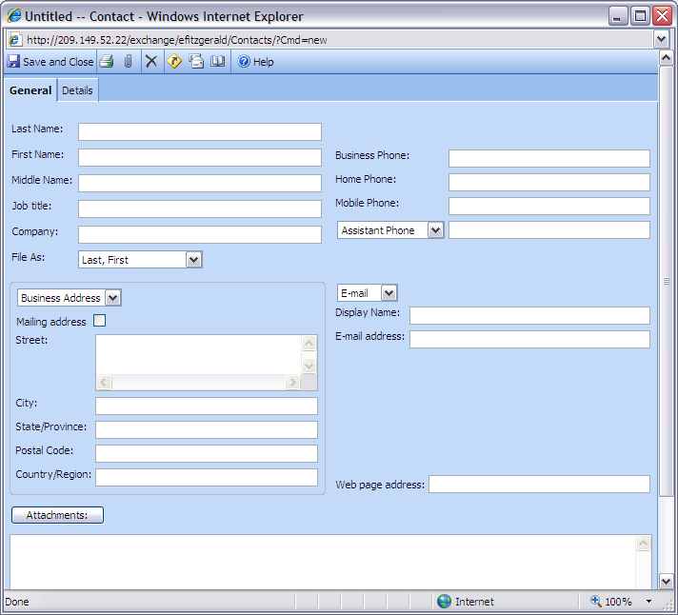
- Click on Contacts
- Click New
- Fill in the information

To add a signature
- Click Options
- Click Edit Signature
- Create your signature in the box
click save and close

